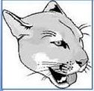

Kernodle Middle School

Counseling Department

**Parent Information Session – Wednesday, 2/19/2025 @ 6:30pm**

The Kernodle Counseling Department will host a rising 6th grade information session for families on Wednesday, February 19th from 6:30 – 7:30pm at Kernodle in the Commons Area. Slides used during the presentation will be posted on the [Kernodle Counseling webpage](https://www.gcsnc.com/domain/23141) for families unable to attend.

Dear rising 6th grade families,

Believe it or not, it is that time of the school year already – time to start thinking about registration for the 2025-2026 school year and entering middle school! This newsletter contains information to help you understand the registration process and to help you select courses for 6th grade. Page 1 has information about the registration process, and Pages 2 and 3 contain course descriptions for 6th grade classes. Page 4 has step-by-step instructions for entering course requests in NCEdCloud.

We look forward to meeting you all and working with you in middle school! If you have any questions or concerns about registration, please feel free to email us.

Ms. Spagnardi Mr. Adachi

[spagnas@gcsnc.com](mailto:spagnas@gcsnc.com) [adachik@gcsnc.com](mailto:adachik@gcsnc.com)

Rising 6th grade for 2025-26

**Registration Process**

**2/14 – 2/23/2025** - Students should enter course requests for 6th grade in PowerSchool (look for “Class Registration” screen). Detailed instructions for entering course requests can be found on Page 4 of this newsletter.

Some elementary schools may use a paper form to help families with course selections. However, online course requests entered in PowerSchool are used to create schedules for students. If your elementary school uses a paper form, please be sure to also enter course requests in PowerSchool.

**2/24 – 3/28/2025** - Counselors will review course requests from February 24 – March 28. Families will receive a copy of your child’s course requests during this window. You should contact your elementary school counselor if you would like to make any changes to course requests during this window.

Please note that final Math and Language Arts class placement will be determined at a later date and based on district criteria.

Middle School Registration Notes

NotesNotes

**6th Grade Core Academic Course Descriptions**

(Middle School Registration Booklet can be accessed at <https://www.gcsnc.com/Page/28797>)

When entering course requests in PowerSchool, families will enter requests for Language Arts and for Math. Final placement decisions for Language Arts and for Math will be made at a later date based on district criteria.

All students will be assigned grade-level Science and Social Studies (no course request to be entered in PowerSchool).

**Language Arts 6 –** This class develops word analysis, vocabulary development, reading comprehension, listening, speaking, and study skills. Students will read literary and informational texts from a variety of genres, subjects, authors, and styles with increasing complexity throughout the year. Students analyze a variety of texts by comparing and contrasting themes or topics. Students will edit their work for sentence formation, usage, mechanics, and spelling.

**Advanced Language Arts 6 –** Students who are identified as AG in reading are guaranteed placement in advanced sections. This course goes into greater depth by using more complex texts and goes at a faster pace to allow for exposure to a greater number and variety of high-level texts and extensions into above grade-level objectives.

**Math 6** **–** Standard math course for most students in North Carolina. Students will develop concepts and skills outlined in the 6th-grade North Carolina Standard Course of Study. Instructional time will focus on four critical areas: (1) connecting ratio and rate to whole-number multiplication and division using concepts of ratio and rate to solve problems; (2) completing students’ understanding of division of fractions and extending the notion of number to the system of rational numbers, which includes negative numbers; (3) writing, interpreting, and using expressions and equations; and (4) developing students’ understanding of statistical thinking.

**Accelerated Math 6** **–** This course is typically for students who score Level 4 on Math EOG. Accelerated Math 6 differs from the standard Math 6 course in that it contains an additional 60% of the content from 7th grade. The additional content demands a faster pace for instruction and learning. Instructional time will focus on the four 6th-grade critical areas (see description of Math 6 for more details). Students will also extend their knowledge of proportional reasoning, statistics, and operations with rational numbers. Students who also successfully complete the optional summer Bridge to Math 1 course (covering key concepts in 8th grade content) may begin high school NC Math 1 in 7th grade.

**AIMM** **–** This course is typically for students who score Level 5 on Math EOG. AIMM (Accelerated Integration of Middle Math) is a rigorous course for students wishing to skip Accelerated Math 7 to enroll in NC Math 1 during 7th grade. Like Accelerated Math 6, AIMM covers 100% of the 6th grade content plus 60% of the 7th grade content during the school year. Successful completion of the optional summer Bridge to Math 1 course (covering key concepts in 8th grade content) may be required (strongly encouraged) to begin high school NC Math 1 in 7th grade.

**Science –** Sixth-grade science is a combination of life, physical, and earth science Essential Standards. The following units of study are taught through the process of scientific inquiry: • Matter: Atoms & Changes in Matter • Energy: Conservation and Transfer of Thermal and Electromagnetic Energy • Energy: Properties of Waves, Including Light Waves and Sound Waves • Earth Systems, Structures, and Processes • Structure and Function of Living Organisms (Plants) • Ecosystems: Flow of Energy & Biomes • Earth’s Place in the Solar System

**Social Studies –** The World Studies I course is an infused study of History, Behavioral Sciences, Geography and Environmental Literacy, Economics and Financial Literacy, Civics and Government, and Inquiry-based skills. These strands are not taught in isolation but woven together to form a course that helps students understand the world in which we live. Students will focus on the emergence, expansion, and decline of civilizations from the Paleolithic Era to 1400 CE. They will understand key factors that shaped the development of civilizations, studying various societies and regions from Africa, Asia, Europe, the Americas, the Caribbean, and the Pacific Islands. Students will systematically examine the histories and cultures of various world regions, including the development of economic, political, and social systems. They will learn and practice historical-thinking skills, including constructing and interpreting historical narratives and using disciplinary-specific reading skills to analyze primary and secondary source documents.

**6th Grade Encore Course Descriptions**

(Full descriptions in the Middle School Registration Booklet <https://www.gcsnc.com/Page/28797>)

**PE/Health (Year-long Encore requirement)** – All students at Kernodle have PE/Health every day. In Health, students will learn about healthy behaviors and potential for health risks. The Physical Education component teaches skills necessary for participation in a variety of team and individual sports and lifetime activities.

In addition to PE/Health, families will request four semesters of encore choice in PowerSchool from the courses listed below (and two alternates that are different from primary choices). Requests can be any combination of year-long and semester-long encores that equals four semesters. Families can request the following combinations:

* Two Year-long Encores
* One Year-long Encore PLUS two Semester-long Encores
* Four Semester-long Encores

**Year-long Encore Course Descriptions** (Two semesters long – meets each day for entire school year)

**Band –** No experience necessary… just interest & positive attitude! Choose from the following instruments: flute, clarinet, alto saxophone, trumpet, trombone, or baritone. Auditions for percussion may occur later in the school year. Students will participate in performances several times during the school year. 6th grade is the ONLY opportunity for students to begin in band while in middle school or high school. Families must provide an instrument for their child.

**Orchestra** – No experience necessary… just interest & positive attitude! Choose from the following instruments: violin, viola, cello, or bass. Students will participate in performances several times during the school year. 6th grade is the ONLY chance for students to begin in orchestra while in middle school or high school unless taking private lessons (can request audition to join in 7th or 8th grade). Families must provide an instrument for their child.

**Chorus (Year-long option)** – You don’t have a be a good singer, but it helps if you want to get better! Year-long Chorus gives students an in-depth study of vocal technique and choral literature. Students will participate in performances several times during the school year.

**Semester-long Encore Course Descriptions** (One semester long – meets each day for half of school year)

**Chorus (Semester-long option)** – You don’t have a be a good singer, but it helps if you want to get better! Semester-long Chorus gives students a basic study of vocal technique and choral literature. Students may participate in performances during the school year. Perfect for students who want to participate in chorus but also want to explore a greater number of encore options.

**Art** – Explore basic art techniques & media. Students develop art appreciation by learning art history.

**Computer Skills & Applications** – Learn basic computer skills & programs that will help you in school and in business. Focus will be on word-processing skills like document formatting of letters, memos, tables, and reports.

**Computer Science Discoveries** – Great for students who are interested in computer programming, computer science, & game design. Create simple computer programs while studying programming concepts, computational thinking, & digital citizenship.

**Exploring Careers & Employment** – Team and whole class modules with hands-on activities help students identify careers of interest and develop employability skills that will serve them in further education and the workplace. The common goal is to provide opportunities to learn about career and education pathways and to build employability skills. Emphasis is placed on self-awareness, understanding the world of work, and the career planning process.

**Intro to Spanish** – Students are introduced to basic Spanish & learn geography, customs, & traditions of the Spanish-speaking world. This course is NOT required to take Spanish later in middle school or in high school.

**2025-2026 Kernodle Middle Online Registration Portal Instructions – RISING 6TH GRADE**

* Go to[**https://my.ncedcloud.org**](https://my.ncedcloud.org) to log in to NCEdCloud **student** account
* Select PowerSchool Student, then click “Class Registration” on left side of screen, and follow directions below
* Online registration window is 2/14-2/23. Parents will receive a copy of requests. If there are concerns, please contact your child’s elementary school counselor.

**Main Screen**

* Students must choose a total of four semesters of encore classes AND two alternates
* Yearlong = 2 semesters
* Semester-long = 1 semester
* Click on pencil icon on right side of screen to select Yearlong encores, Semester Encores, or Encore Alternates (see screens below)
* After completing encore choices, click “**Submit**” to complete online registration

**Yearlong Encores (Two semesters)**

* Select up to 2 Yearlong Encores and click “Okay” to confirm Yearlong Encores
* Any course that is selected in this section **WILL** be assigned to a student
* Chorus = Semester long option available (see Semester Encores section). Students cannot have both yearlong and semester long Chorus
* Band/Orchestra are both yearlong classes

**Semester Encores (One semester)**

* Select up to 4 Semester Encores and click “Okay” to confirm Semester Encores
* Students may select any of the Semester Encores
* Chorus = Students cannot have both yearlong and semester long Chorus

**Encore Alternates**

* Select 2 Encore Alternates and then click on “Okay” to confirm Encore Alternates
* Students **MUST** choose two Encore Alternates that have not been used as a yearlong/semester encore selection

**ELA** and **Mathematics**

* Select 1 course request for ELA and 1 for Math
* ELA and Math classes will be determined at a later date based on district criteria

**PE/Health** and **Science** and **Social Studies**

* All students will be assigned these classes

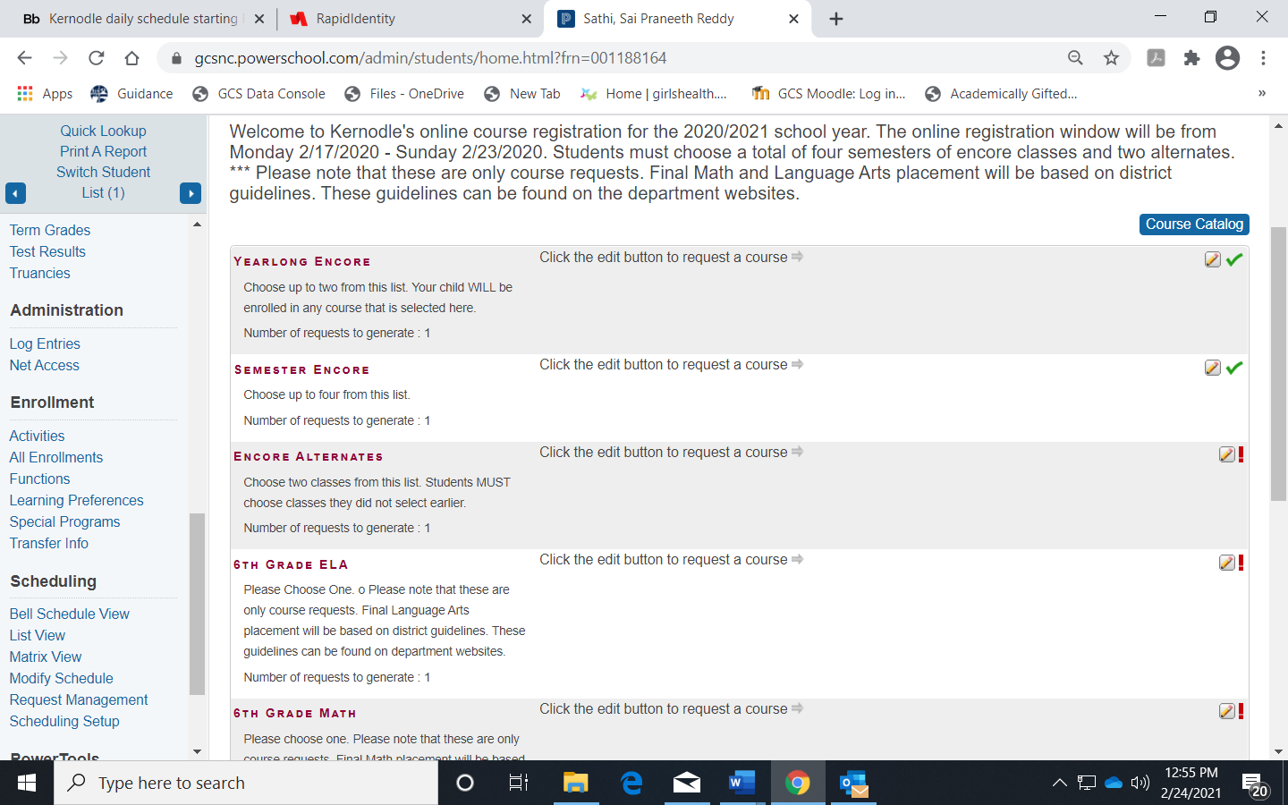

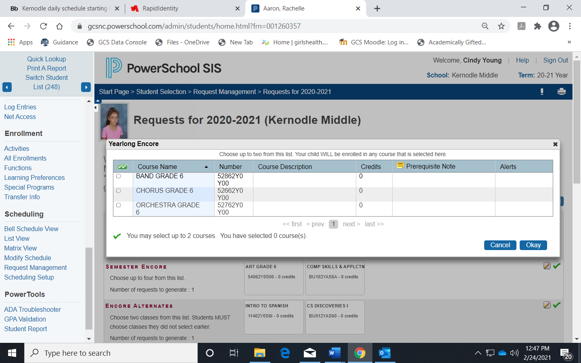

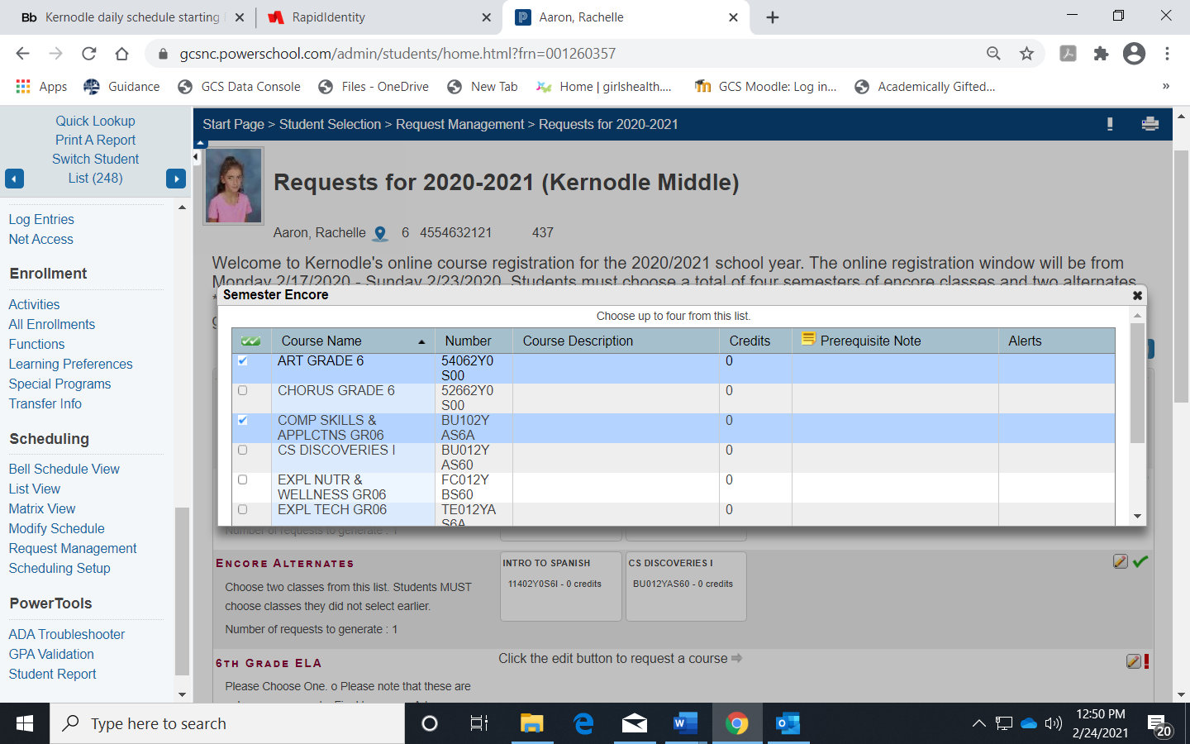

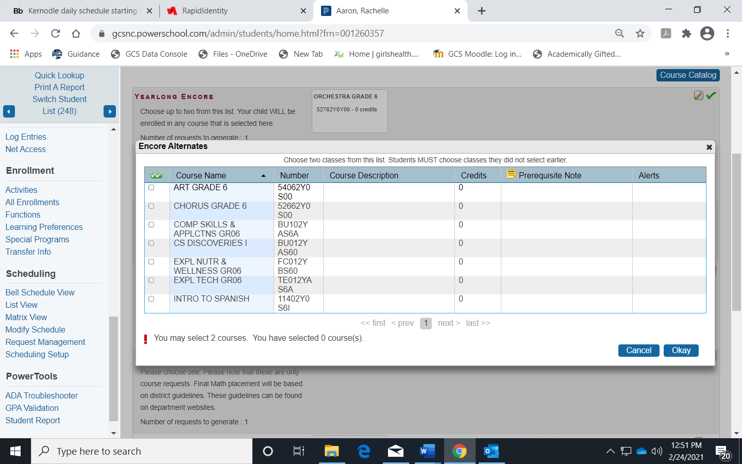

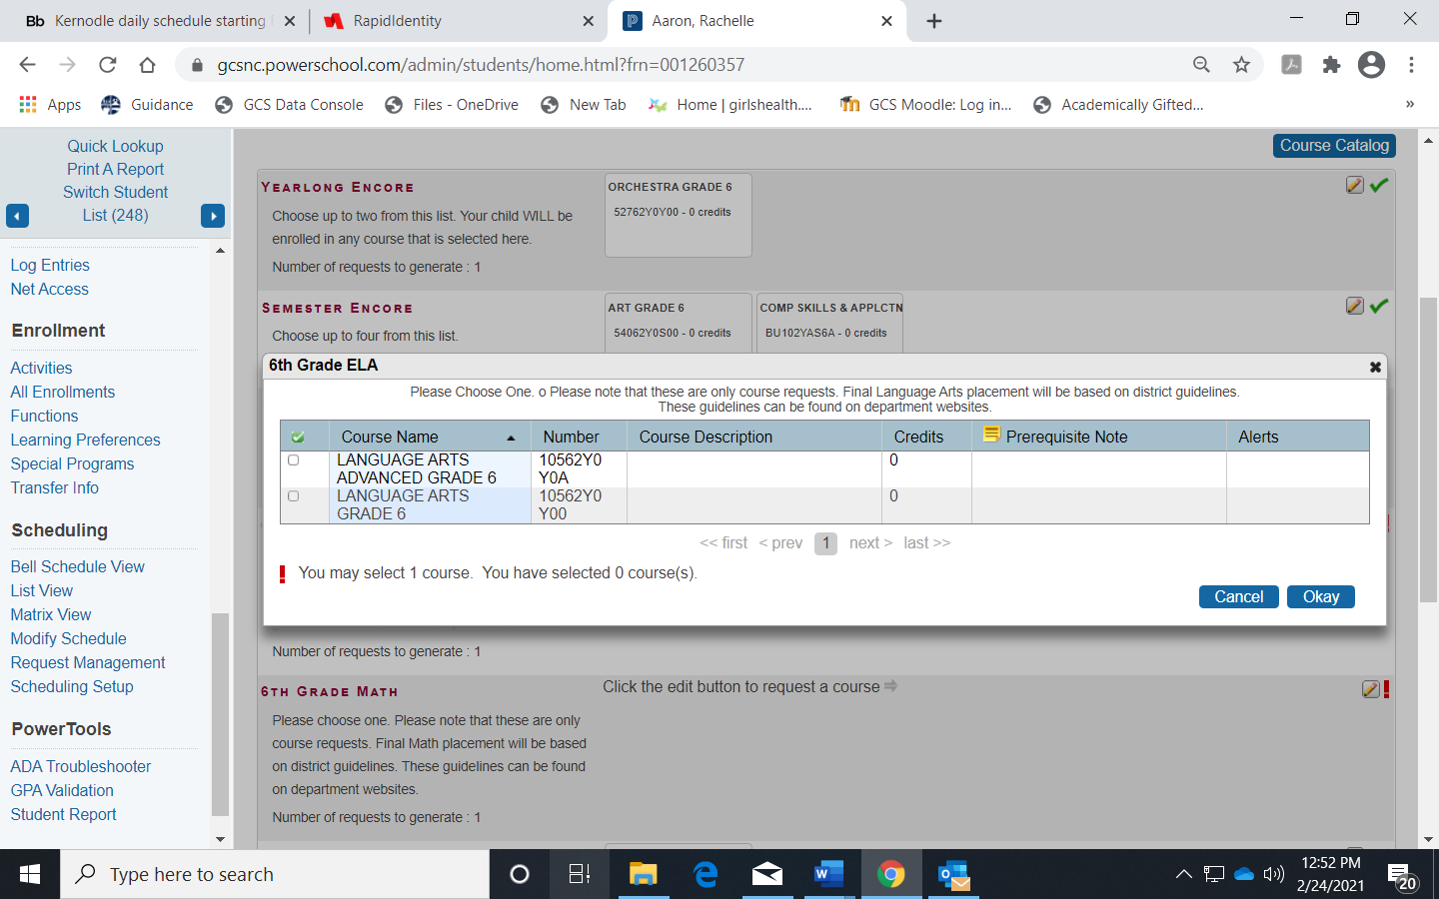

February 2025

Dear Parent/Guardian:

This letter provides important information regarding the 2025 – 2026 course registration process at Kernodle Middle School. The resources and information below will help guide decisions about your son’s/daughter’s course selections and help them reach the next stage of academic progress.

Kernodle Middle School will host a parent information session on Wednesday, February 19th, at 6:30pm in the Commons Area.

You can access the link to the online version of the registration book at <https://www.gcsnc.com>, search for Registration Toolbox – Registration Books. The registration book contains information about the multitude of choices in GCS and is designed to help you and your student make the best choices for their middle/high school education and post-secondary opportunities. Your son/daughter will register for his/her course selections using the Online Course Registration. The registration window will open for Kernodle Middle School from February 14 – February 23. Parents/guardians may review their son’s/daughter’s 2025-2026 course selections by accessing the PowerSchool Parent Portal. You may find the parent portal on our school’s webpage by clicking the tab for Parents – PowerSchool Parent Portal.

During the window from 2/24 – 3/28/2025, students will receive a copy of their course selections for the 2025-2026 school year. Please take time to review and discuss your son’s/daughter’s course selections. We encourage students to take advantage of rigorous coursework as GCS is proud to offer courses and programs that will prepare students for educational and career opportunities after high school.

Sincerely,

Sydney Spagnardi – (email: spagnas@gcsnc.com) – counselor for all rising 6th grade students, and rising 8th grade students last names M-Z.

Kaz Adachi – (email: [adachik@gcsnc.com](mailto:adachik@gcsnc.com)) – counselor for all rising 7th grade students, and for rising 8th grade students last names A-L

Kernodle Middle School

336-545-3717